NEW OBJECTIVES: Review the Rules of Exponents.
Exponent Rule: | Symbolism: | In plain English ...
Zero Exponent | x⁰ = 1 | All numbers (not zero) raised to the zero power equal one.
Negative Exponent | 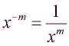 | A negative exponent tells you that the factor is on the wrong side of the fraction bar. ( x is not zero).
Product Rule | 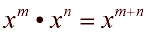 | When multiplying, and the bases are the same, ADD the exponents.
Quotient Rule | 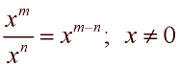 | When dividing, and the bases are the same, SUBTRACT the exponents. (top exponent subtract bottom exponent)
Power to a Power | 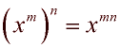 | When raising a power to a power, MULTIPLY the exponents.
Product to a Power | 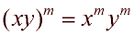 | When raising a product to a power, EACH factor gets raised to the new power.
Quotient to a Power | 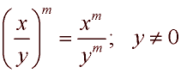 | When raising a quotient to a power, BOTH top and bottom get raised to the new power.
Monday, 2.17.25 No Class, Student Holiday

Wednesday, 2.19.25

Review the Exponential Rules.

Class Work/Homework:
Directions: Decide whether the following statements are TRUE or FALSE. Assume any variables represent a positive quantity.
TRUE | FALSE

TRUE | FALSE

TRUE | FALSE

TRUE | FALSE

TRUE | FALSE

Look carefully!
TRUE | FALSE

TRUE | FALSE

TRUE | FALSE

TRUE | FALSE

TRUE | FALSE

Friday, 2.21.25

Practice: Simplifying Exponential Expressions

Class Work/Homework: Maxwell’s Mowing

